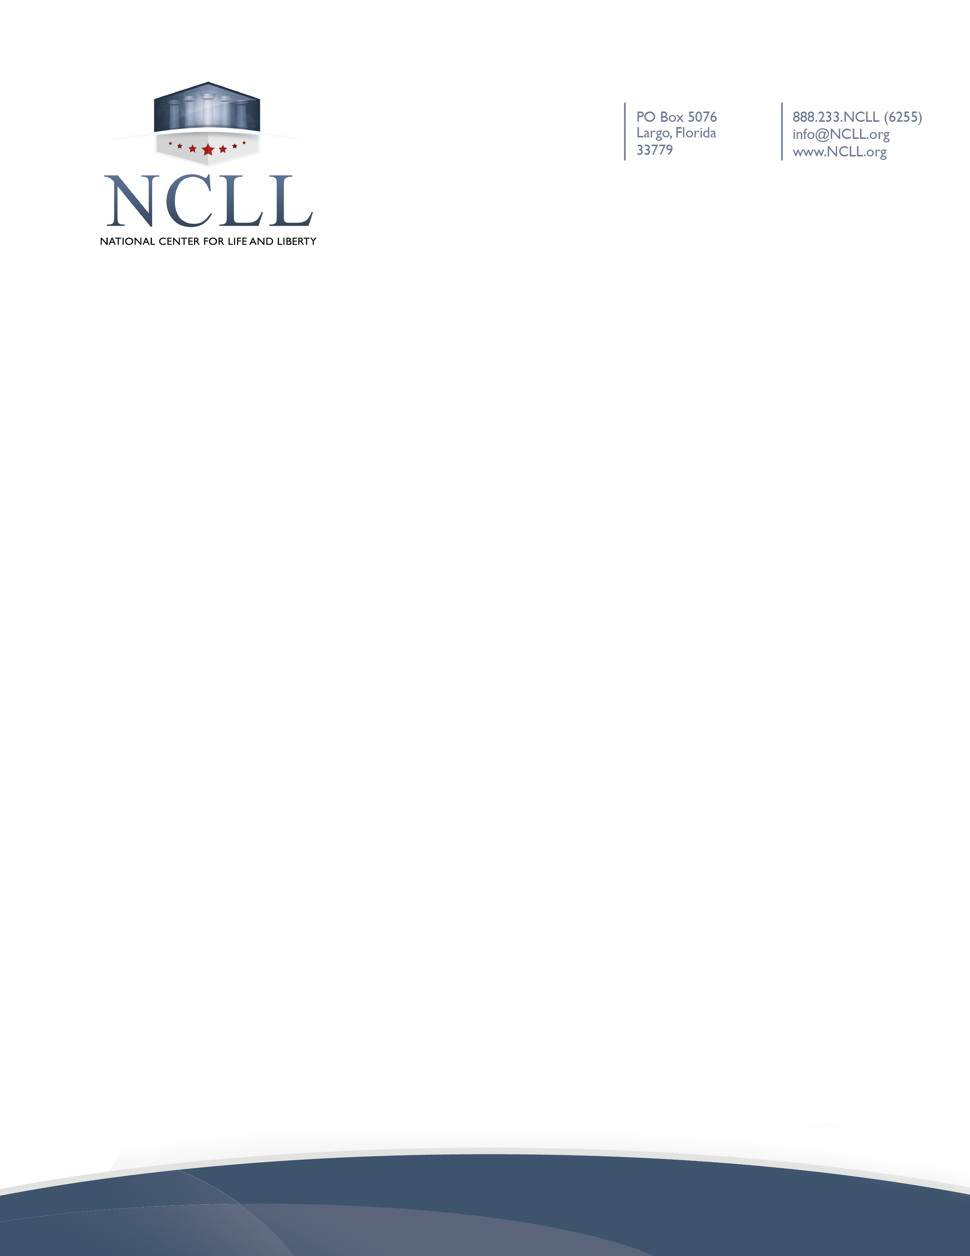

Date

Church Name
Address
City, State, Zip Code

RE: Disclosure of potential COVID-19 exposure

Dear Parent,

The administration would like to make you aware that a student (or staff member) in our school has been exposed to COVID-19. According to our policy, the student (or staff member) will be (insert your policy: receiving a COVID-19 test) and our school community is being alerted to potential exposure.

Due to HIPAA requirements, this is the extent of the information we can provide concerning this student (or staff member). Our recommendation is to monitor your family closely for symptoms, and if anyone in your family presents any symptoms, have them (insert your policy: tested) and follow school protocols in place for your student.

Please let us know if you have any concerns. We appreciate your support during this unprecedented time.

Sincerely,

Administration Signature

