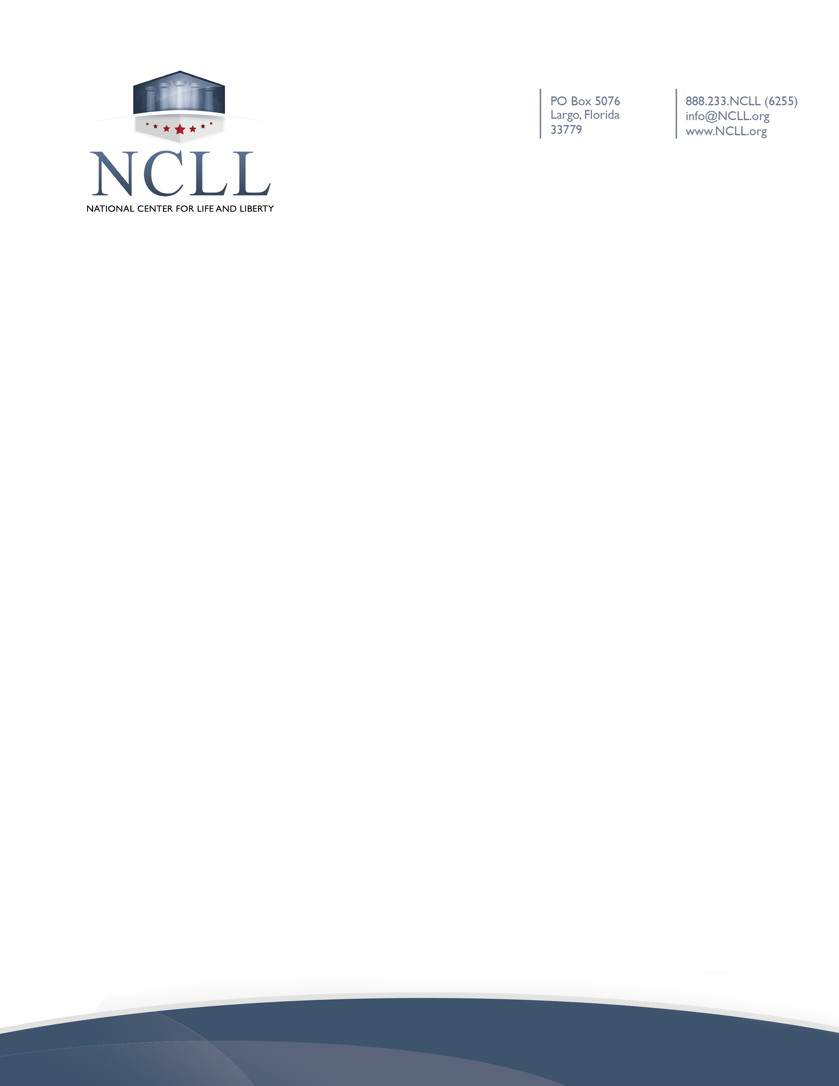

Waiver of Liability Relating: Coronavirus/COVID-19
On March 11, 2020, The World Health Organization declared the novel coronavirus, COVID-19, a pandemic. COVID-19 is highly contagious and is believed to spread mainly from person-to-person contact. As a result, federal, state, and local governments and federal and state health agencies recommend social distancing and have, in many locations, prohibited the congregation of groups of people over the past several weeks. [Organization/Ministry Name] (the “Ministry”) has put precautions in place to reduce the spread of COVID-19; however, the Ministry cannot guarantee that you or your family, including your child(ren), will not become exposed to or infected with COVID-19. Further, because of the number of individuals involved in [name of activity] and the fact that many infected individuals appear to be asymptomatic, attending this activity could increase your and your child(ren)’s risk of contracting COVID-19.
By signing this waiver, I acknowledge the contagious nature of COVID-19 and voluntarily assume the risk that my child(ren) and I may be exposed to or infected by COVID-19. I also acknowledge that by attending [name of activity], such exposure or infection may result in personal injury, illness, disability, and/or death. I understand that the risk of becoming exposed to or infected by COVID-19 at [name of activity] may result from the actions, omissions, or negligence of myself and others, including, but not limited to, Ministry employees, contractors, volunteers, members, and participants and their families.
I voluntarily agree to assume all of the foregoing risks and accept sole responsibility for any injury to my child(ren) or myself (including, but not limited to, personal injury, disability, and death), illness, damage, loss, claim, liability, or expense of any kind that I or my child(ren) may experience or incur in connection with my child(ren)’s attendance at the Ministry or participation in [name of the event] (“Claims”). On my behalf, and on behalf of my children, I hereby release, covenant not to sue, discharge, and hold harmless the Ministry, its employees, agents, and representatives, of and from the Claims, including all liabilities, claims, actions, damages, costs or expenses of any kind arising out of or relating thereto. I understand and agree that this release includes any Claims based on the actions, omissions, or negligence of the Ministry, its employees, agents, and representatives, whether a COVID-19 infection occurs before, during, or after participation in any program.

Signature of Parent/Guardian | Date
Print Name of Parent/Guardian | Name of Participant(s)

