

{Date}

{Name of Church}

{Address}

{City, State, Zip}

To Whom It May Concern:

[Insert Name] is a volunteer or employee of [Church or Ministry Name], which is an essential business as defined by the local and state mandates. As such, this employee is exempt from mobility restrictions when reporting to or returning from work or while performing [his / her] duties.

Please direct any questions to our legal counsel, Attorney David Gibbs III with The National Center for Life and Liberty at (727) 362-3700 or by email at [david@ncll.org](mailto:david@ncll.org).

Sincerely,

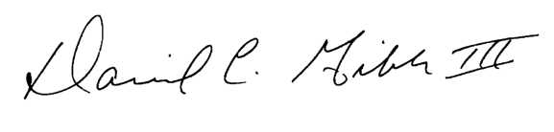

David C. Gibbs III