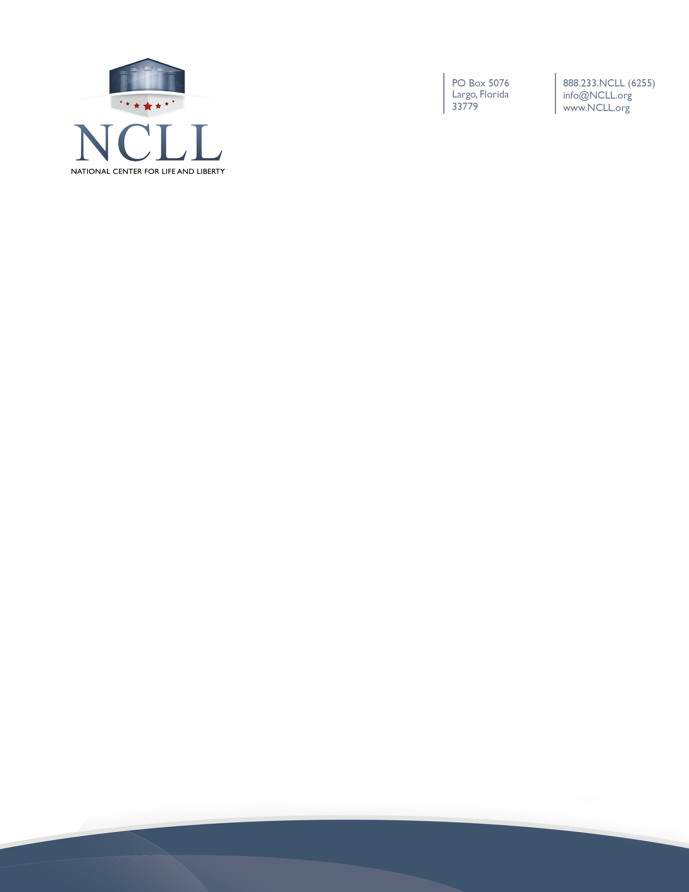

Statement of Waiver of Liability and Assumption of Risk
Related to Coronavirus/COVID-19

COVID-19 is highly contagious and is known to spread mainly from person-to-person contact. By attending [Name of Church/Ministry] (the “Ministry”), you agree to abide by the procedures established by the church to protect attendees and staff, and you voluntarily assume the risk that you and/or your family may be exposed to or infected by COVID-19 either at the church, in the church worship service, or in the nursery or Sunday School. You agree to assume all the risks of attendance and participation for you and your family, and you waive any liability against the church and any other parties.

