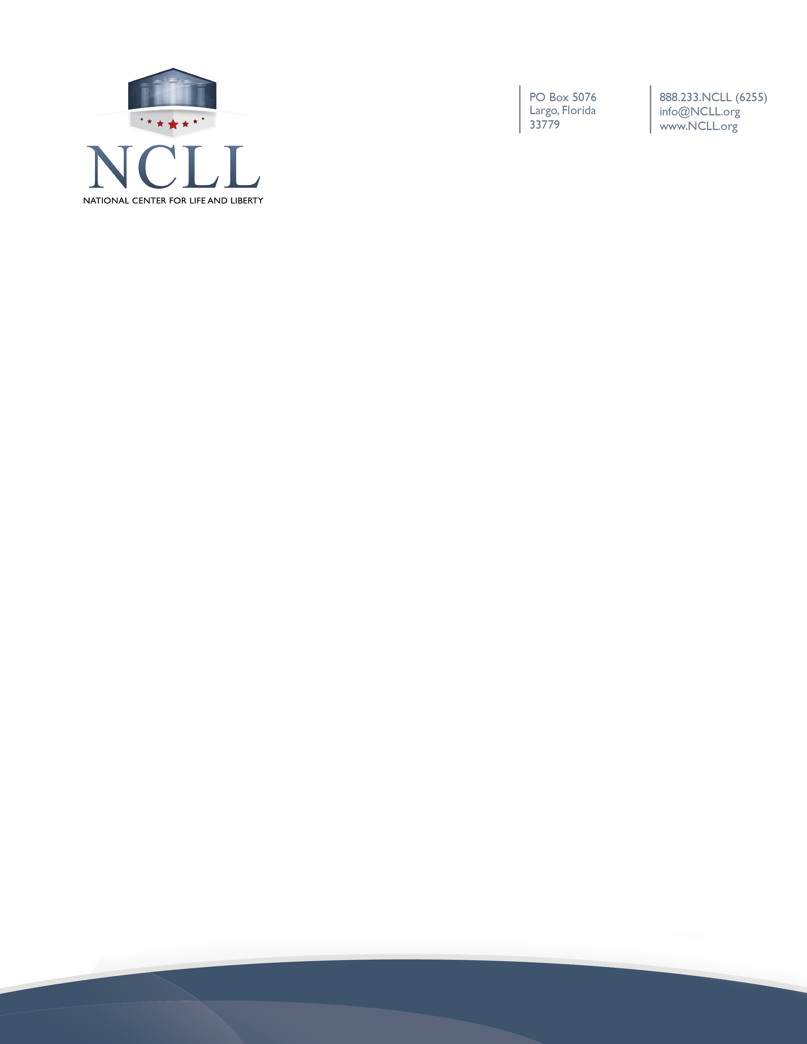

Statement of Waiver of Liability and Assumption of Risk
Related to Coronavirus/COVID-19

On March 11, 2020, the World Health Organization declared the novel coronavirus, COVID-19, a pandemic. COVID-19 is highly contagious and known to spread mainly from person-to-person contact. As a result, federal, state, and local governments and federal and state health agencies recommend social distancing and have, in many locations, prohibited the congregation of groups of people over the past several weeks.
By attending [Name of Church/Ministry] (the “Ministry”), you acknowledge the contagious nature of COVID-19 and voluntarily assume the risk that you and your family may be exposed to or infected by COVID-19. You also acknowledge that the risk of becoming exposed to or infected by COVID-19 may result from the actions, omissions, or negligence of yourself and/or others, including, but not limited to, Ministry employees, contractors, volunteers, members, and participants and their families. You agree to assume all the foregoing risks, waive liability against the Ministry and any other listed parties, and accept sole responsibility for any illness, injury, disability, or death to you or your family, including all claims that may arise resulting from any of these.

